Co-3 Assessment tool-1

Q1) R code:
response_time <- c(118, 121, 125, 127, 129, 131, 134, 136, 138, 141,
144, 147, 151, 156, 162, 171, 184, 205, 249, 318)

library(ggplot2)

data <- data.frame(response_time)

ggplot(data, aes(x = response_time)) +
stat_ecdf(geom = "step") +
labs(title = "ECDF of Response Time",
x = "Response Time (ms)",
y = "Cumulative Probability") +
theme_minimal()

ggplot(data, aes(sample = response_time)) +
stat_qq() +
stat_qq_line() +
labs(title = "Normal Q-Q Plot of Response Time",
x = "Theoretical Quantiles",
y = "Sample Quantiles") +
theme_minimal()

Output:
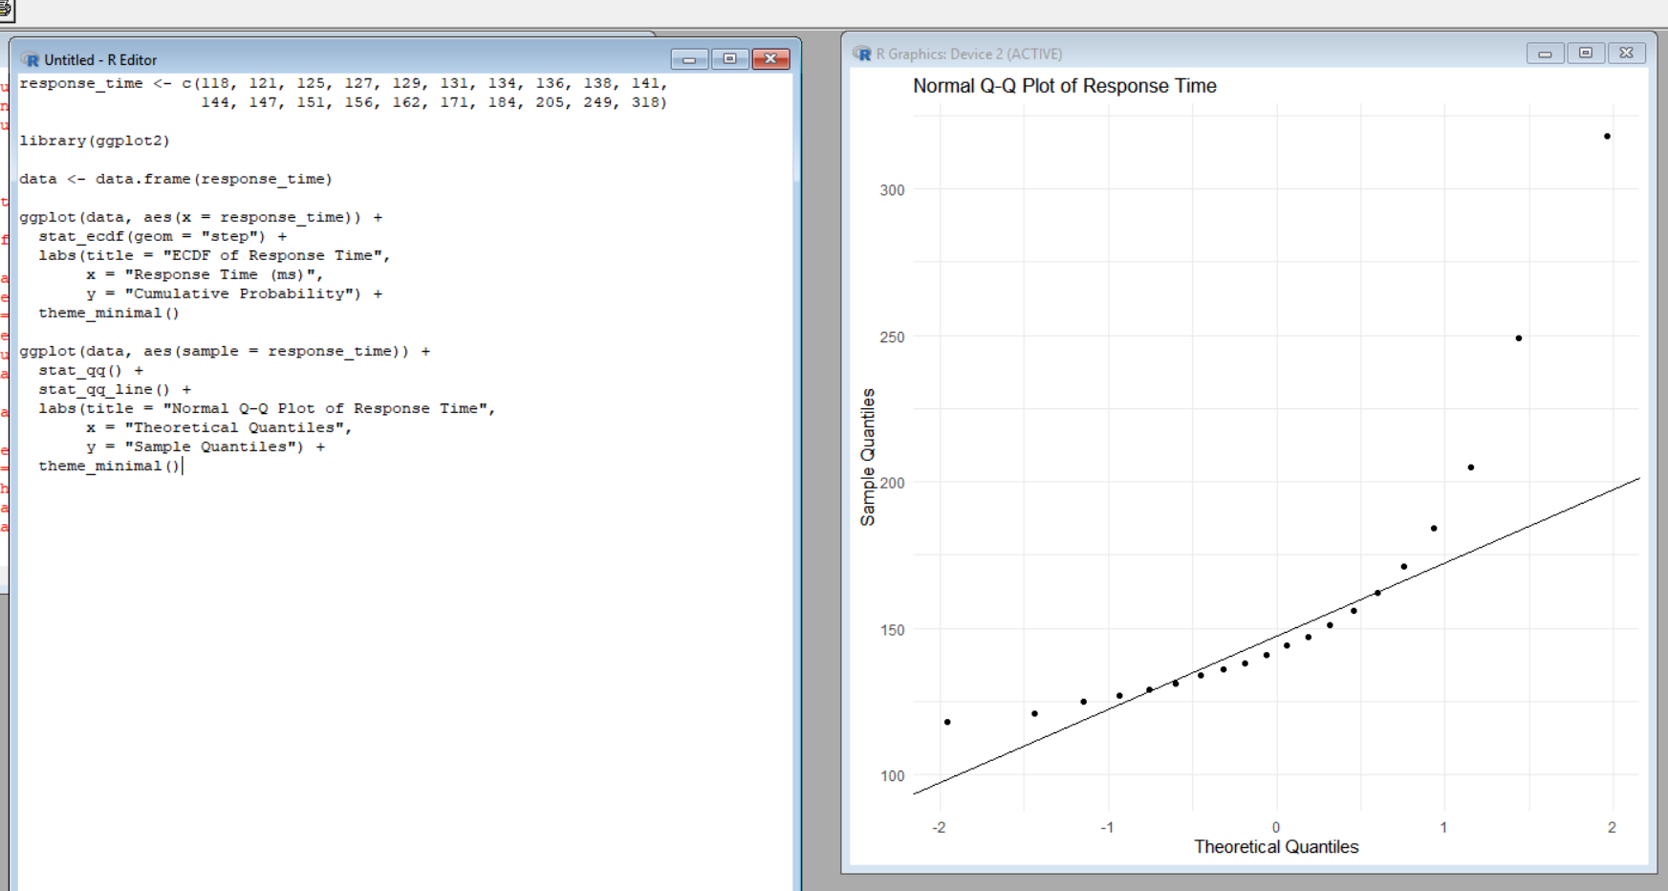

Interpretation
- The ECDF shows how response times accumulate across the 20 test runs.
- Most observations are concentrated between approximately 118 ms and 184 ms.
- The values 205, 249, and 318 ms form a long upper tail.
- Therefore, the distribution shows positive/right skewness.
- In the Q-Q plot, the points are expected to lie close to the reference line if the data are normally distributed.
- The large response times, especially 249 ms and 318 ms, would deviate substantially from the line.
- Hence, the claim that the response time is approximately normal is not strongly supported.
Recommendation
Percentile-based limits are recommended rather than mean ± standard deviation.
Justification:
The data contain a strong right tail and extreme observations. Mean and standard deviation can be strongly influenced by these high response times. Percentiles are more robust and provide a better representation of the actual response-time distribution.
Final Conclusion:
The response-time data are right-skewed and contain extreme observations, so using percentile-based monitoring limits is more appropriate than assuming normality and using mean ± standard deviation. This follows the experiment's focus on ECDF, Q-Q plots, skewness, outliers, and distribution interpretation.

Q2) i. R code distribution comparison
library(ggplot2)

data <- data.frame(
Line = rep(c("L1", "L2", "L3", "L4"), each = 10),
CycleTime = c(
42,44,45,46,47,48,49,50,51,53,
38,41,44,47,50,53,56,59,62,65,
45,46,46,47,47,48,48,49,49,50,
40,41,42,43,44,45,48,55,61,72
)
)

ggplot(data, aes(x = Line, y = CycleTime)) +
geom_boxplot() +
labs(
title = "Cycle Time Distribution by Production Line",
x = "Production Line",
y = "Cycle Time (minutes)"
) +
theme_minimal()

Output:
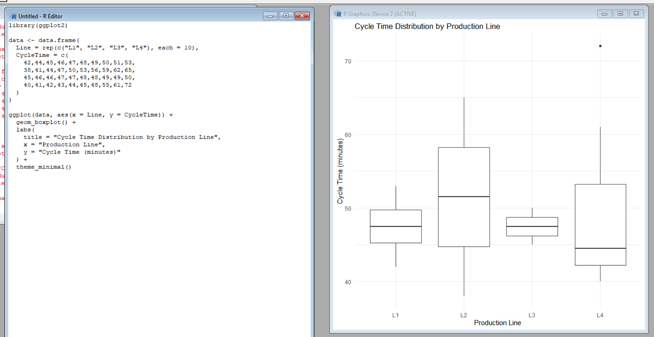

ii. R code for bean plot:
library(ggplot2)

data <- data.frame(
Line = rep(c("L1", "L2", "L3", "L4"), each = 10),
CycleTime = c(
42,44,45,46,47,48,49,50,51,53,
38,41,44,47,50,53,56,59,62,65,
45,46,46,47,47,48,48,49,49,50,
40,41,42,43,44,45,48,55,61,72
)
)

ggplot(data, aes(x = Line, y = CycleTime)) +
geom_violin(trim = FALSE) +
geom_jitter(width = 0.08, size = 2) +
labs(
title = "Bean Plot Equivalent of Cycle Time",
x = "Production Line",
y = "Cycle Time (minutes)"
) +
theme_minimal()
Output:
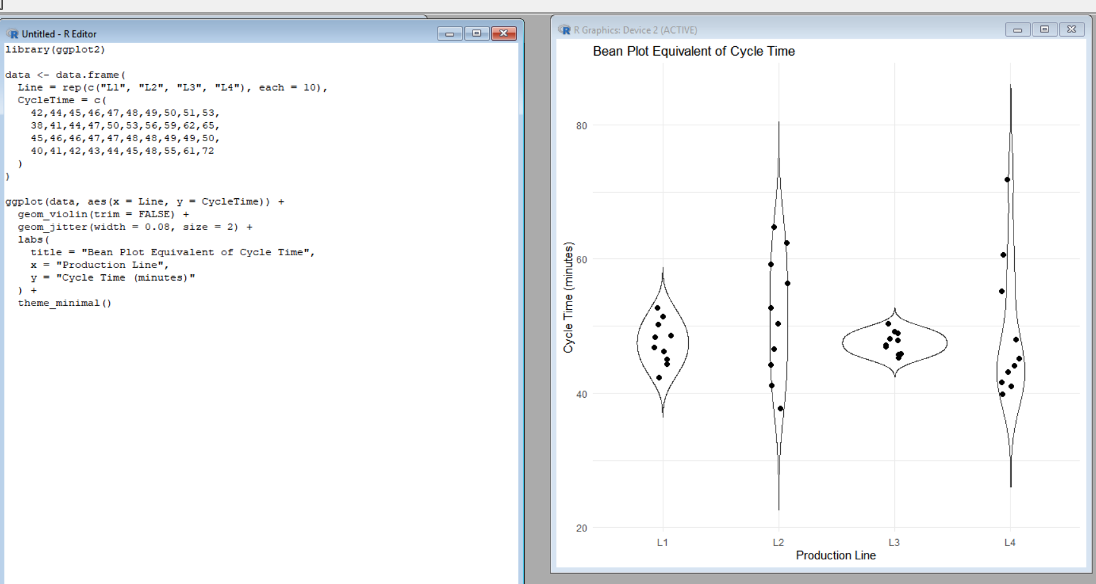

Interpretation
- L1 has a relatively narrow distribution, with cycle times between 42 and 53 minutes.
- L2 has a wide and steadily increasing distribution, ranging from 38 to 65 minutes.
- L3 is the most concentrated distribution, with values mainly between 45 and 50 minutes.
- L4 has the greatest variability, ranging from 40 to 72 minutes, with particularly high values at 61 and 72 minutes.
Greatest Variability
L4 has the greatest variability because its cycle times have the widest spread (40–72 minutes) and contain high extreme observations.
Most Concentrated Distribution
L3 is the most concentrated because almost all observations fall within a very small range (45–50 minutes).
Why Comparing Only Means Is Insufficient ?
Comparing only means can hide important differences in spread, skewness, concentration, and extreme observations. Two production lines may have similar average cycle times but very different variability. Therefore, distribution plots such as violin/bean plots provide more information than means alone.
Conclusion
L4 requires attention because of its high variability, while L3 shows the most consistent production performance. A distribution-based comparison is therefore more informative than comparing only average cycle times.

Q3) i. R code for side by side bar chart
library(ggplot2)

data <- data.frame(
Department = rep(c("CSE", "ECE", "IT"), each = 3),
Mode = rep(c("Online", "Blended", "Face-to-Face"), 3),
Percentage = c(52, 28, 20, 45, 35, 20, 30, 40, 30)
)

ggplot(data, aes(x = Department, y = Percentage, fill = Mode)) +
geom_bar(stat = "identity", position = "dodge") +
labs(
title = "Learning Mode Preference by Department",
x = "Department",
y = "Percentage (%)"
) +
theme_minimal()
Output:
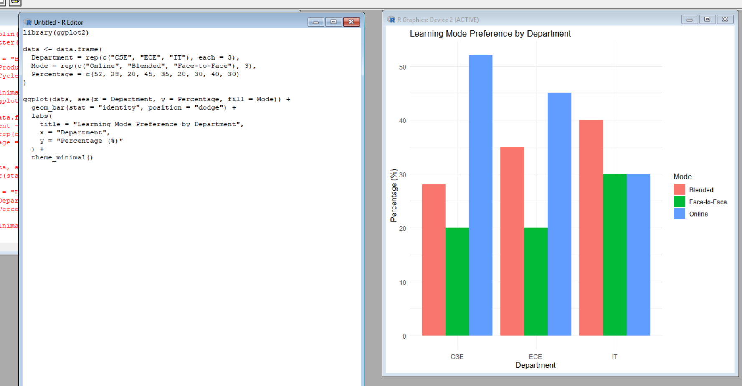

ii. R code stacked bar chart:
library(ggplot2)

data <- data.frame(
Department = rep(c("CSE", "ECE", "IT"), each = 3),
Mode = rep(c("Online", "Blended", "Face-to-Face"), 3),
Percentage = c(52, 28, 20, 45, 35, 20, 30, 40, 30)
)

ggplot(data, aes(x = Department, y = Percentage, fill = Mode)) +
geom_bar(stat = "identity", position = "fill") +
scale_y_continuous(labels = scales::percent) +
labs(
title = "100% Stacked Learning Mode Preferences",
x = "Department",
y = "Proportion"
) +
theme_minimal()
Output:
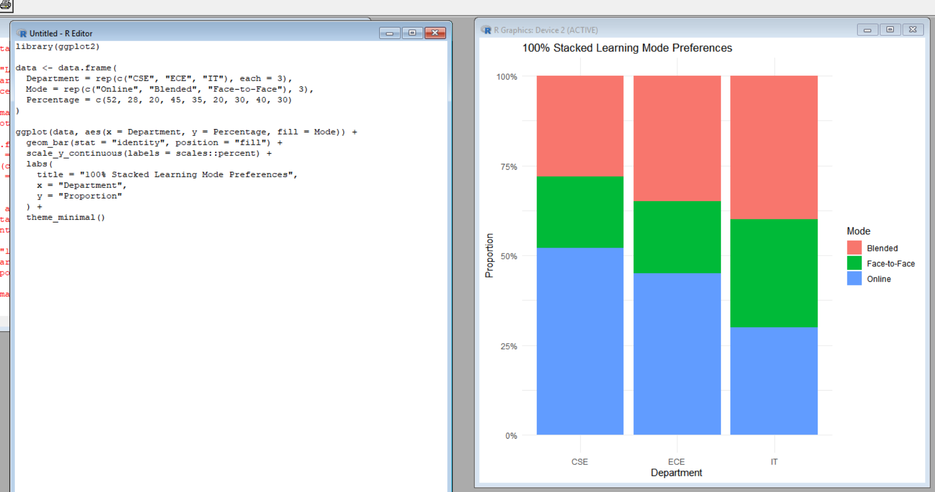

Interpretation
- Better chart for individual proportion:
- comparison:
The side-by-side bar chart is better because each learning mode has a separate baseline, making it easier to compare individual percentages across departments.
2. Why separate pie charts are less effective:
Separate pie charts require the viewer to compare angles and areas across different charts. This makes small differences harder to identify than aligned bars.
3. Design choice that can exaggerate small differences:
Using a truncated y-axis in a bar chart can make small percentage differences appear much larger than they actually are.
Conclusion:
The side-by-side bar chart is the better choice when the main goal is comparing individual proportions across departments, while the 100% stacked bar chart is useful for showing the overall composition of each department.

Q4) R code for Treemap:
library(ggplot2)
library(treemapify)

data <- data.frame(
Category = c(
"Electronics", "Electronics", "Electronics",
"Home", "Home", "Home",
"Fashion", "Fashion", "Fashion"
),
Subcategory = c(
"Mobiles", "Laptops", "Accessories",
"Furniture", "Appliances", "Decor",
"Men", "Women", "Kids"
),
Revenue = c(24, 18, 8, 14, 10, 6, 7, 8, 5)
)

ggplot(data, aes(
area = Revenue,
fill = Category,
label = Subcategory,
subgroup = Category
)) +
geom_treemap() +
geom_treemap_subgroup_border() +
geom_treemap_text(colour = "white", place = "centre") +
labs(
title = "Revenue by Category and Subcategory",
fill = "Category"
) +
theme_minimal()
Output:
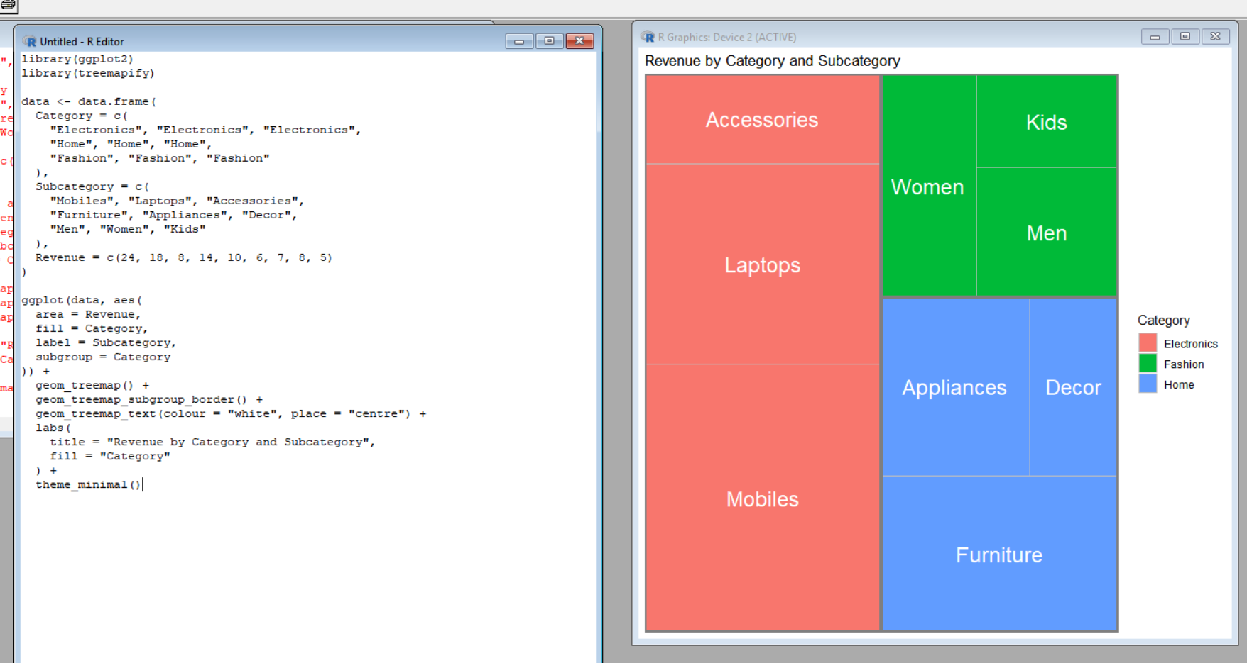

ii. sunburst chart:
install.packages("plotly")

library(plotly)

labels <- c(
"Total Revenue",
"Electronics",
"Home",
"Fashion",
"Mobiles",
"Laptops",
"Accessories",
"Furniture",
"Appliances",
"Decor",
"Men",
"Women",
"Kids"
)

parents <- c(
"",
"Total Revenue",
"Total Revenue",
"Total Revenue",
"Electronics",
"Electronics",
"Electronics",
"Home",
"Home",
"Home",
"Fashion",
"Fashion",
"Fashion"
)

values <- c(
100,
50,
30,
20,
24,
18,
8,
14,
10,
6,
7,
8,
5
)

fig <- plot_ly(
labels = labels,
parents = parents,
values = values,
type = "sunburst",
branchvalues = "total"
)

fig <- layout(
fig,
title = "Revenue Distribution by Category and Subcategory"
)

fig
Output:
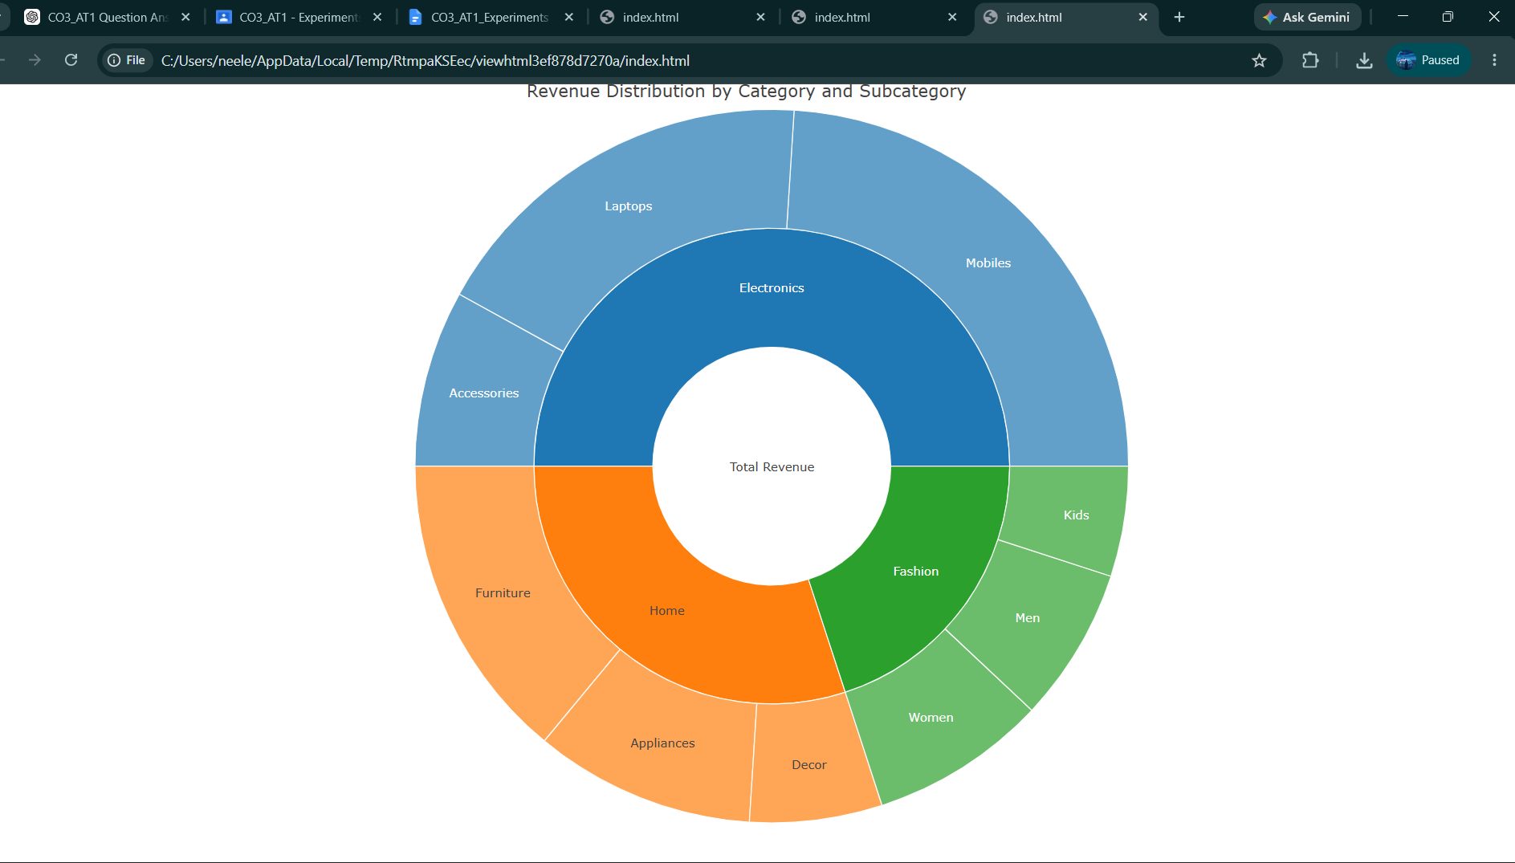

Calculations
Total revenue:
24 + 18 + 8 + 14 + 10 + 6 + 7 + 8 + 5 = ₹100 lakh
The scenario states annual revenue of ₹1.2 crore, but the provided table totals ₹100 lakh (₹1 crore). Therefore, using the supplied data, the percentages should be calculated from ₹100 lakh, not ₹120 lakh.
Category totals:
- Electronics = 24 + 18 + 8 = ₹50 lakh
- Home = 14 + 10 + 6 = ₹30 lakh
- Fashion = 7 + 8 + 5 = ₹20 lakh
Largest Category
Electronics = ₹50 lakh
Percentage:
(50 / 100) × 100 = 50%
Therefore, Electronics contributes 50% of the revenue represented by the supplied table.
Treemap vs Sunburst
- Treemap: Better for comparing revenue using rectangular area and quickly identifying the largest category.
- Sunburst: Better for showing the hierarchical relationship between categories and subcategories.
- Both visualize nested proportions, but the sunburst makes the category → subcategory structure more explicit.
Possible Area-Encoding Bias
Area comparisons can be difficult when rectangles have similar sizes or different aspect ratios. A small difference in area may therefore be difficult for viewers to judge accurately.
Conclusion
The Electronics category is the largest, contributing 50% of the revenue in the provided dataset. The treemap is effective for area-based comparison, while the sunburst is effective for displaying the hierarchy.

Q5) R code for Sankey diagram:
install.packages("networkD3")

library(networkD3)

nodes <- data.frame(
name = c(
"Residential", "Suburban", "Rural",
"Bus", "Train",
"Central", "Industrial"
)
)

links <- data.frame(
source = c(
0, 0, 1, 1, 2, 2,
3, 3, 4, 4
),
target = c(
3, 4, 3, 4, 3, 4,
5, 6, 5, 6
),
value = c(
50, 35, 30, 45, 20, 20,
67, 43, 65, 35
)
)

sankeyNetwork(
Links = links,
Nodes = nodes,
Source = "source",
Target = "target",
Value = "value",
NodeID = "name",
fontSize = 13,
nodeWidth = 30
)
Output:
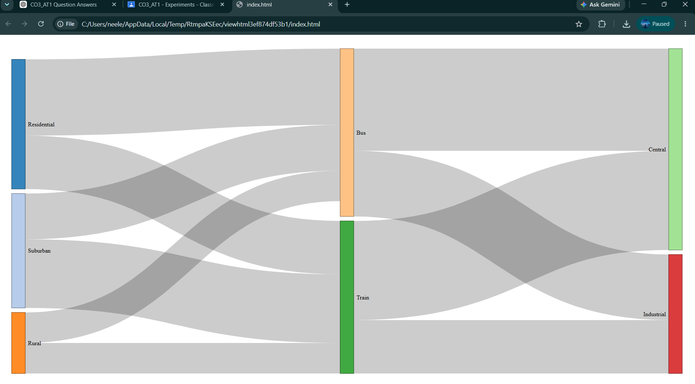

ii. R code for parallel sets:
install.packages("ggforce")

library(ggplot2)
library(ggforce)

data <- data.frame(
Origin = c(
"Residential", "Residential",
"Residential", "Residential",
"Suburban", "Suburban",
"Suburban", "Suburban",
"Rural", "Rural",
"Rural", "Rural"
),
Mode = c(
"Bus", "Bus",
"Train", "Train",
"Bus", "Bus",
"Train", "Train",
"Bus", "Bus",
"Train", "Train"
),
Destination = c(
"Central", "Industrial",
"Central", "Industrial",
"Central", "Industrial",
"Central", "Industrial",
"Central", "Industrial",
"Central", "Industrial"
),
Commuters = c(
35, 15,
25, 10,
20, 10,
30, 15,
12, 8,
10, 10
)
)

data$Origin <- factor(
data$Origin,
levels = c("Residential", "Suburban", "Rural")
)

data$Mode <- factor(
data$Mode,
levels = c("Bus", "Train")
)

data$Destination <- factor(
data$Destination,
levels = c("Central", "Industrial")
)

ggplot(data) +
geom_parallel_sets(
aes(
axes = c(Origin, Mode, Destination),
id = seq_len(nrow(data)),
split = Mode,
value = Commuters
),
alpha = 0.7
) +
geom_parallel_sets_axes(
aes(
axes = c(Origin, Mode, Destination)
)
) +
geom_parallel_sets_labels(
aes(
axes = c(Origin, Mode, Destination)
)
) +
labs(
title = "Parallel Sets of Commuter Flows",
x = "Flow Categories",
y = "Number of Commuters"
) +
theme_minimal()
Output:
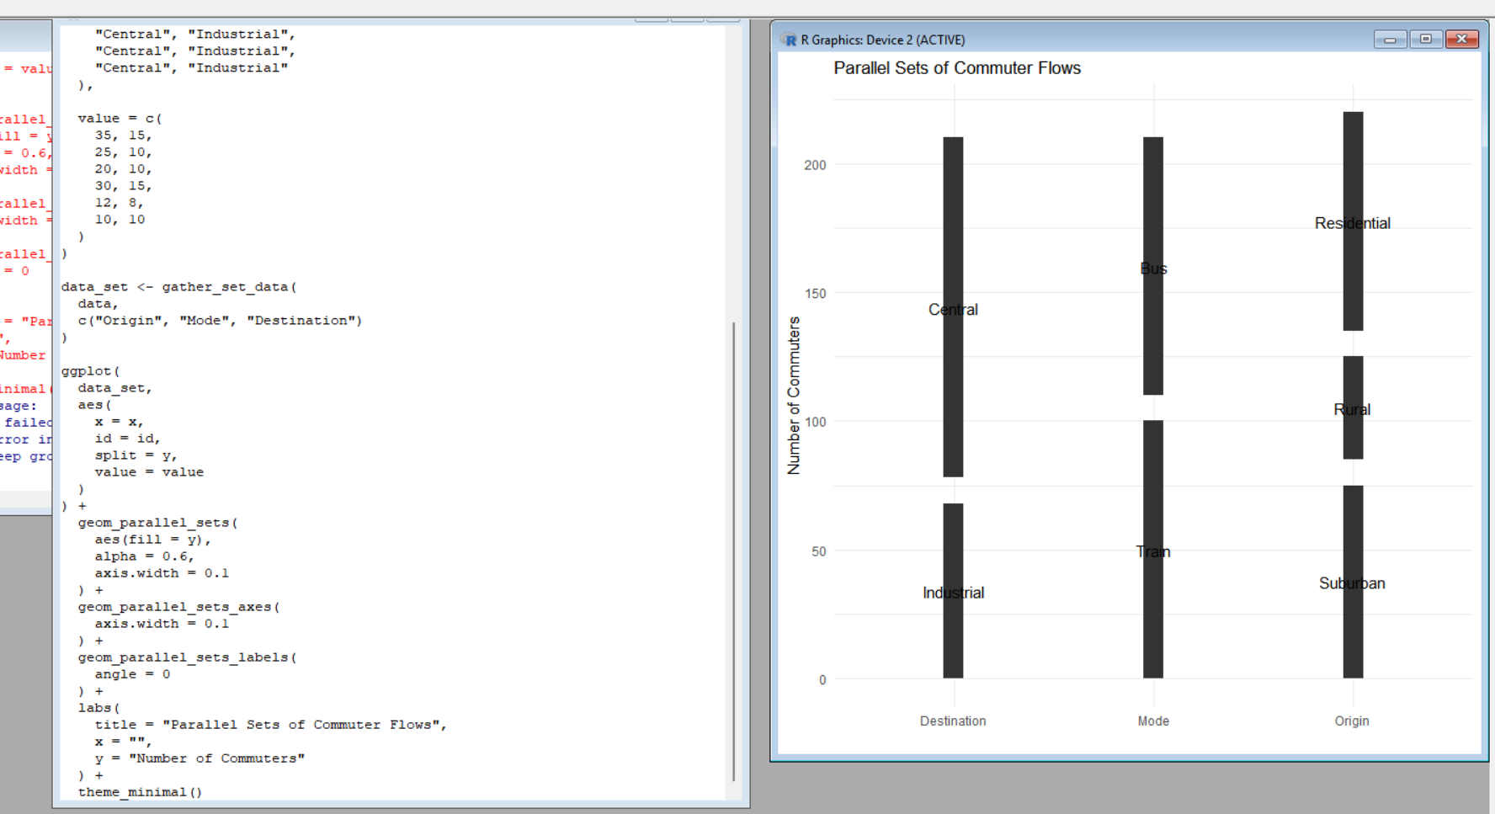

Three Largest Individual Flows
From the given table:
Flow | Commuters | Percentage
Residential → Bus → Central | 35 | 17.5%
Suburban → Train → Central | 30 | 15%
Residential → Train → Central | 25 | 12.5%
Calculation
- 35 / 200 × 100 = 17.5%
- 30 / 200 × 100 = 15%
- 25 / 200 × 100 = 12.5%
Sankey vs Parallel Sets
Sankey diagram: Better for showing the magnitude of flows because link width represents the number of commuters.
Parallel sets: Better for showing relationships between multiple categorical variables, such as Origin → Mode → Destination.
Possible Visualization Bias
Incorrect link widths in a Sankey diagram can make flows appear larger or smaller than their actual values. Similarly, poor category ordering in parallel sets can create unnecessary crossings and make relationships difficult to interpret.
Conclusion
The Sankey diagram and parallel-sets representation effectively show the flow of commuters from origin → transport mode → destination. The largest flow is Residential → Bus → Central, with 35 commuters (17.5%). The visualizations help identify dominant transportation patterns and relationships between categories. Sankey diagrams are better for comparing flow magnitude, while parallel sets are useful for understanding categorical relationships.

